Phase 2 – Org Setup & Configuration
1. Salesforce Edition
Description:
The Salesforce edition determines the available features, number of users, and storage. For this project, a Developer Edition or Trailhead Playground is sufficient.

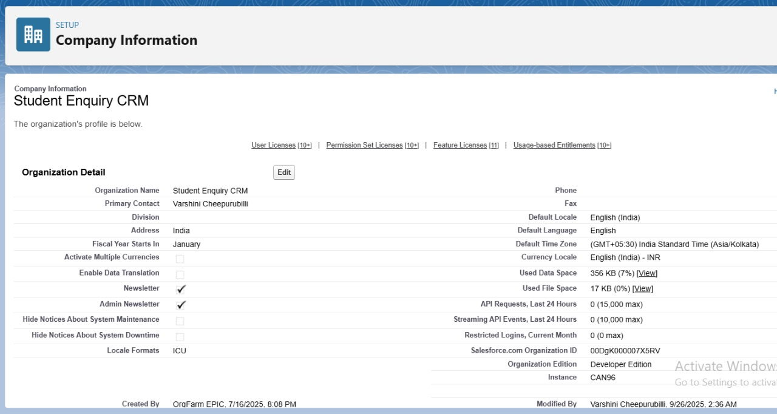
2. Company Profile Setup

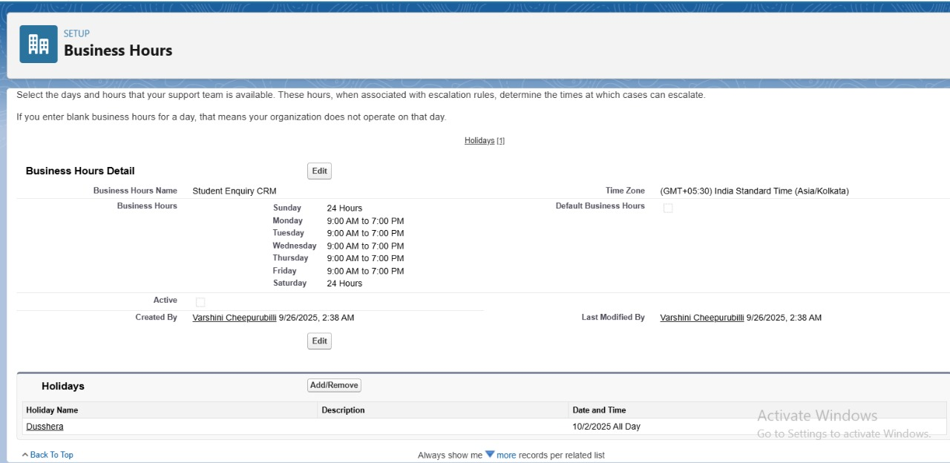
Description:
Company Profile stores organization information such as name, address, default currency, and time zone. Accurate company info is important for reporting, scheduling, and email communications.
Implementation:
Setup → Company Information → Edit → Fill in Name, Address, Default Currency, Time Zone.
3. Business Hours & Holidays
Use Case / Description:
Defines working hours and holidays used in automation and task/case management.
Implementation:
Setup → Business Hours → New → Define hours (e.g., 9 AM – 6 PM, Monday to Friday)
Setup → Holidays → New → Define public holidays

4. Fiscal Year Settings
Use Case / Description:
Defines the organization’s fiscal period, used in reporting and forecasting student conversions.
Implementation:
Setup → Fiscal Year → Use Standard or Custom Fiscal Year → Save

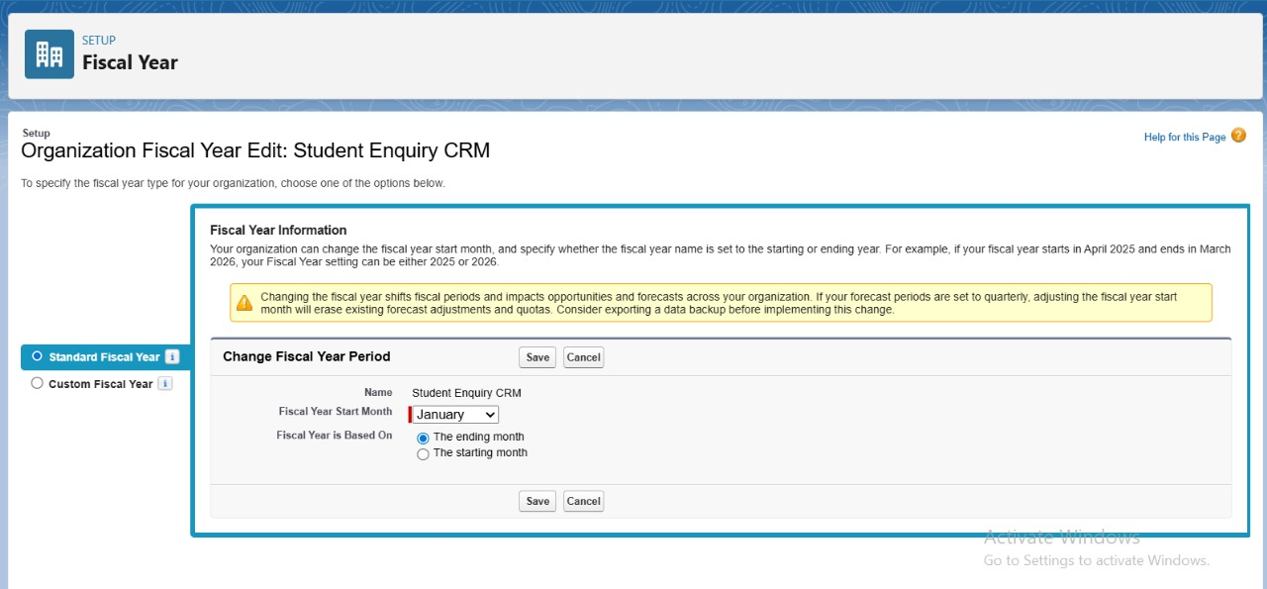

5. User Setup & Licenses
Description:
Users are individuals who can access Salesforce. Licenses determine access level. Roles and profiles control permissions.
Implementation:
Setup → Users → New User → Fill Name, Email, Role, Profile, License

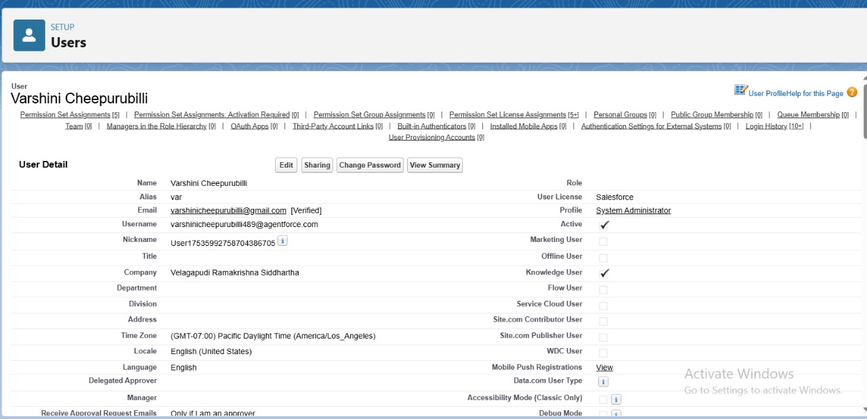

6. Login Access Policies
Description:
Defines login restrictions and security policies to ensure only authorized users access Salesforce.
Implementation:
Setup → Security → Login Access Policies → Enable/Configure
7. Developer Org Setup
Description:
Developer Org or Trailhead Playground is used to build and test the CRM project without affecting production.
Implementation:
Use Trailhead Playground → Connect to Salesforce → Create your objects, fields, and flows
8. Sandbox Usage
Description:
Sandboxes allow testing new features safely without impacting live data. In a beginner project, the Developer Org acts as a sandbox.
9. Deployment Basics – Outbound Change Set
Description:
Outbound Change Sets allow transferring components from one org to another ( Dev Org → Production).

